**Assignment 3.6**

1. Yes, you can overload a method with same return type**. In case of same return type list of arguments should not be same.**

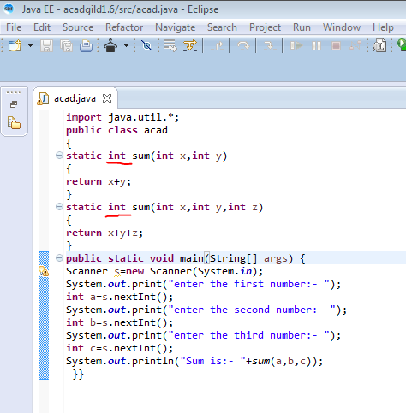

2.  
**import** java.util.*;

**public** **class** acad {

**public** **static** **void** main(String[] args) {

Scanner s=**new** Scanner(System.***in***);

**int** n,a[],b[];

System.***out***.println("enter the no of values you want to sort:");

n=s.nextInt();

System.***out***.println("enter the values");

a=**new** **int**[n];

b=**new** **int**[n];

**for**(**int** i=0;i<n;i++)

{

a[i]=s.nextInt();

}

Arrays.*sort*(a);

System.***out***.print("Descending order:");

**for**(**int** i=0;i<n;i++)

{

b[i]=a[n-i-1];

}

**for**(**int** i=0;i<n;i++)

System.***out***.print(" " +b[i]);}}  
  
OUTPUT:  
